Advanced Topics in Neuroscience HW3

Aliakbar Mahmoodzadeh 98106904

1. **Pre-processing:**

Monkey data has first been pre-processed by the “script_mean_firing_rates.m” file. I chose the default threshold values (SNR_threshold = 1.5, firing rate threshold = 1 spikes/sec

Also, I put the neurons of each monkey that were removed from the data set by using this pre-process. And for each monkey, I save the cleaned data as S_monkey1, S_monkey2, and S_monkey3.

1. **Part 1 – Tuning Curve**

The mean firing rate of the best neurons across 12 grating angles is calculated by averaging over their PSTH. This will result in the tunning curves plot.

Also, I plotted the tuning curve for the most active neuron for each monkey and some random neurons. The red line in each plot shows the most active neuron as well.

**Monkey-1:** 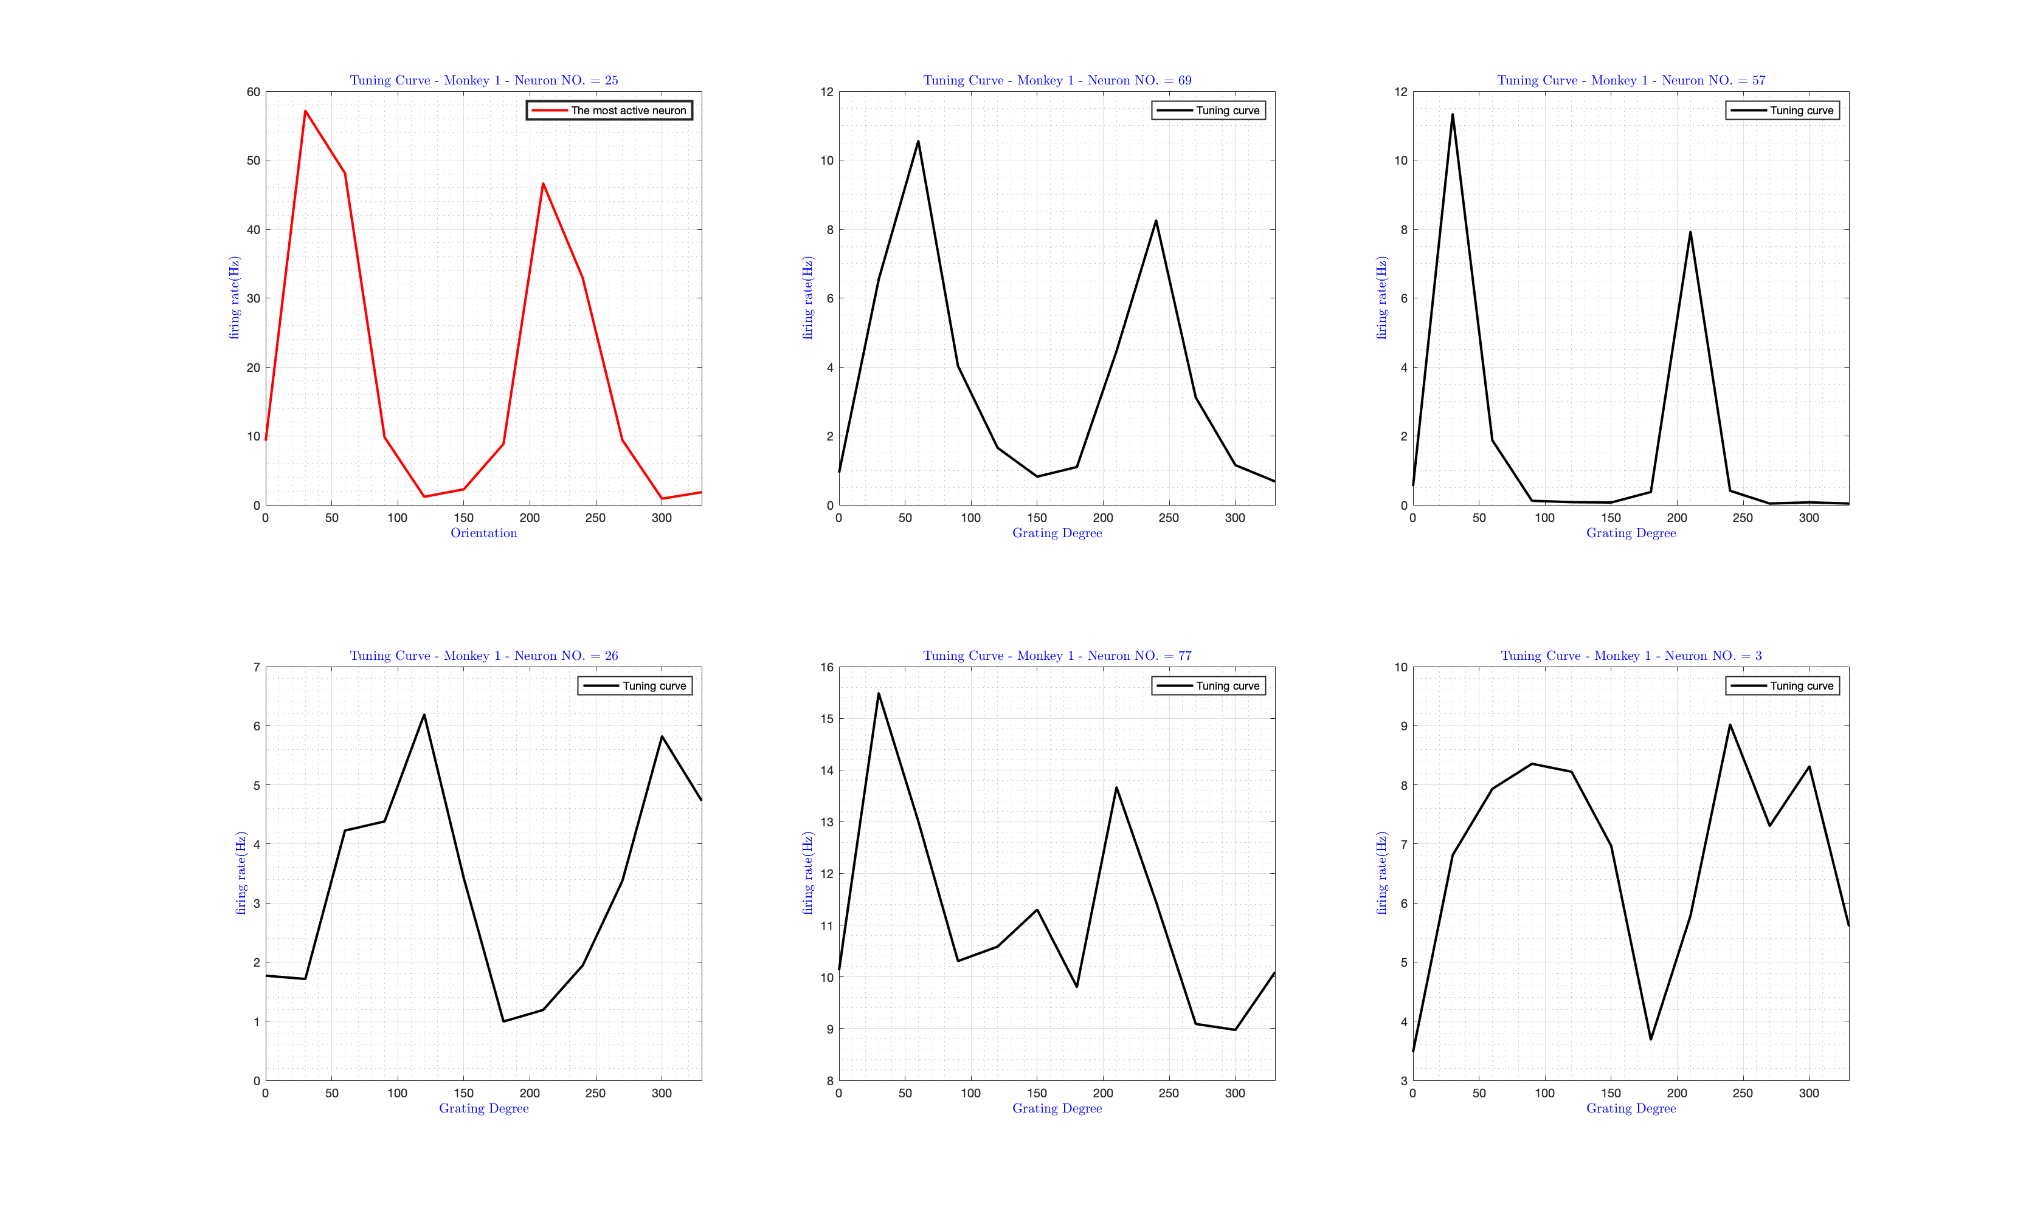

**Monkey-2:** 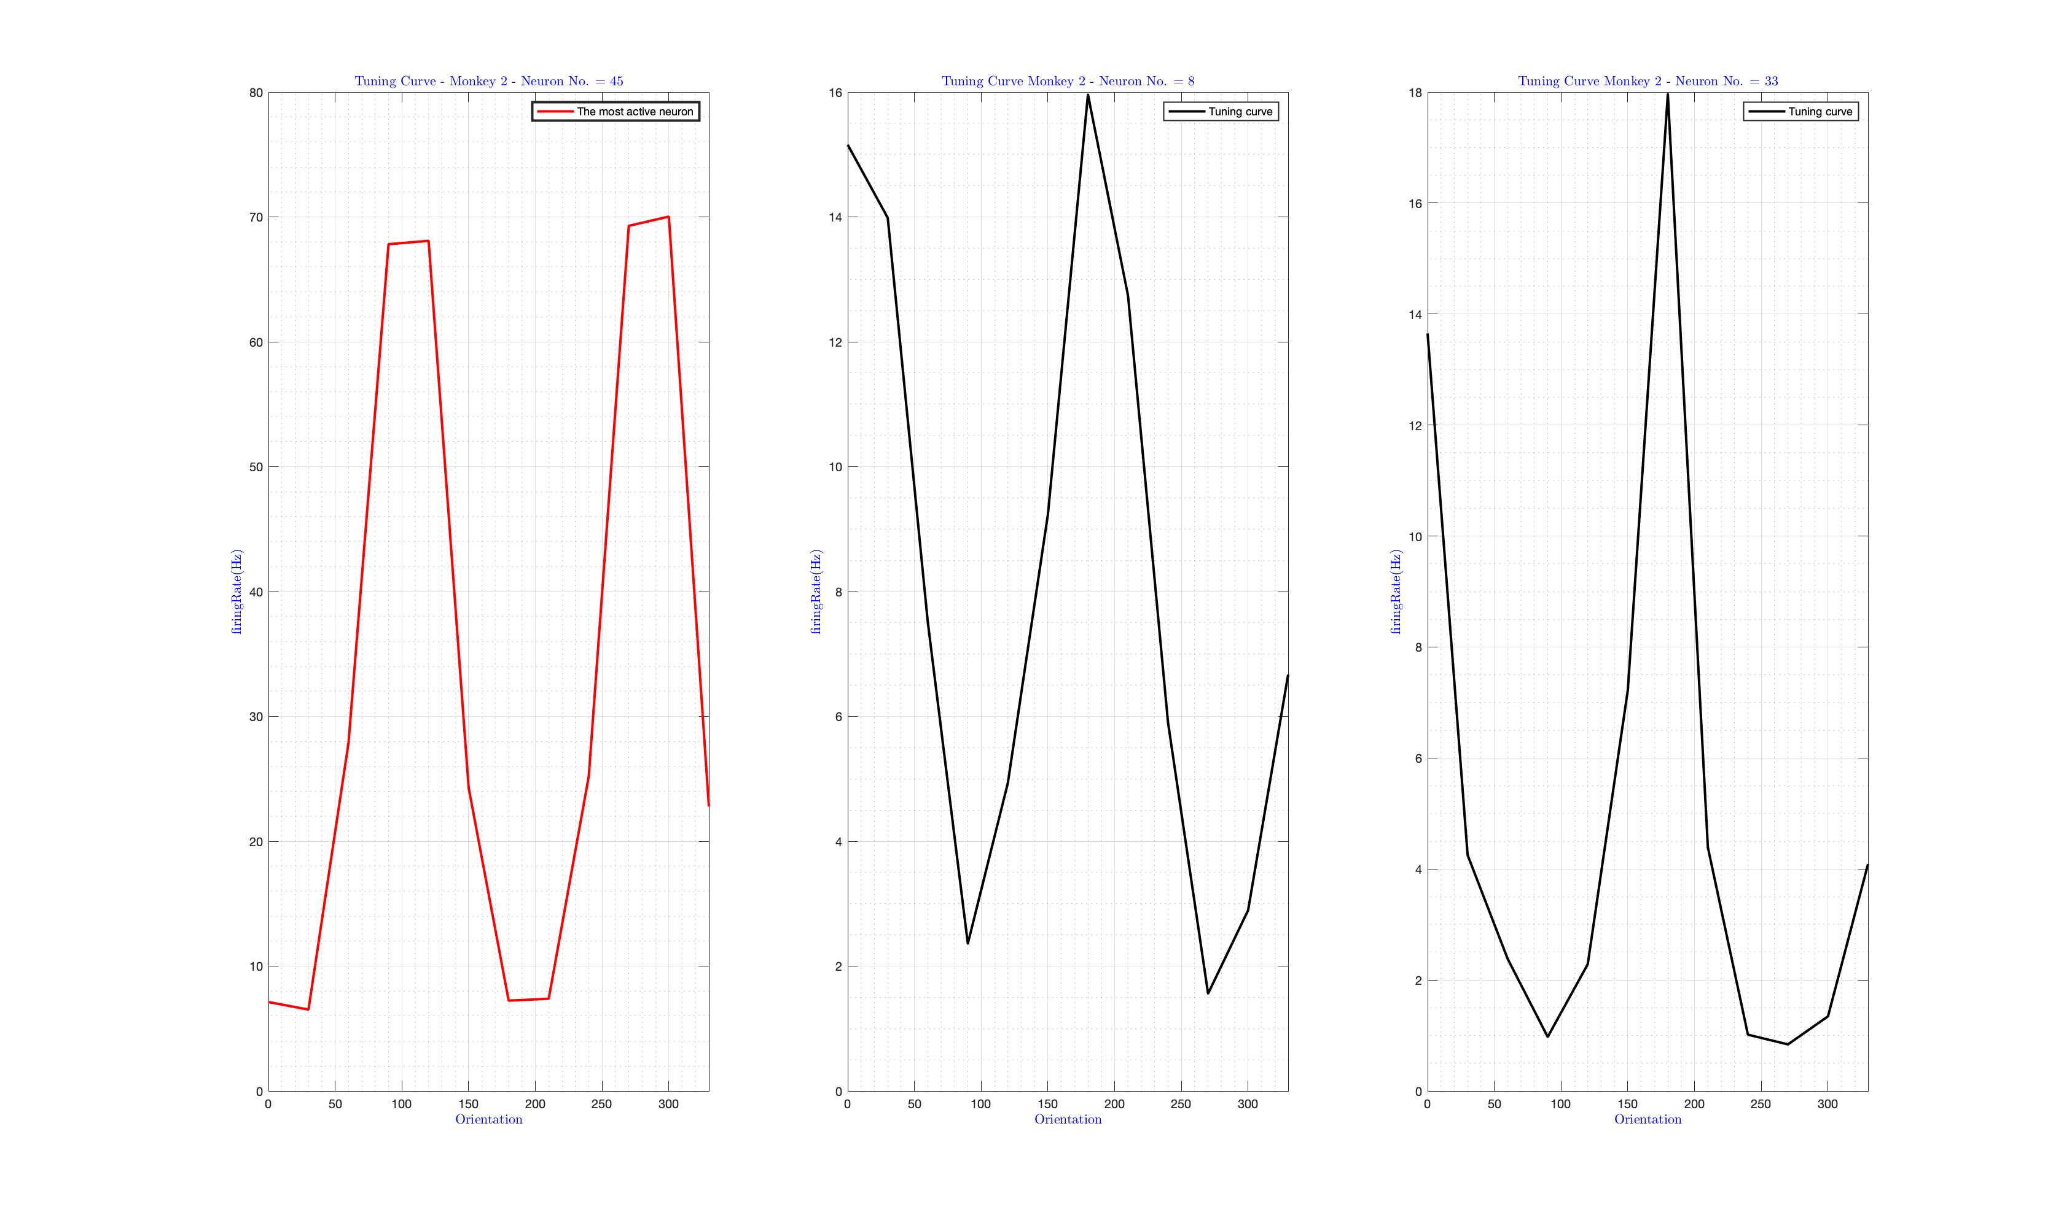

**Monkey-3:** 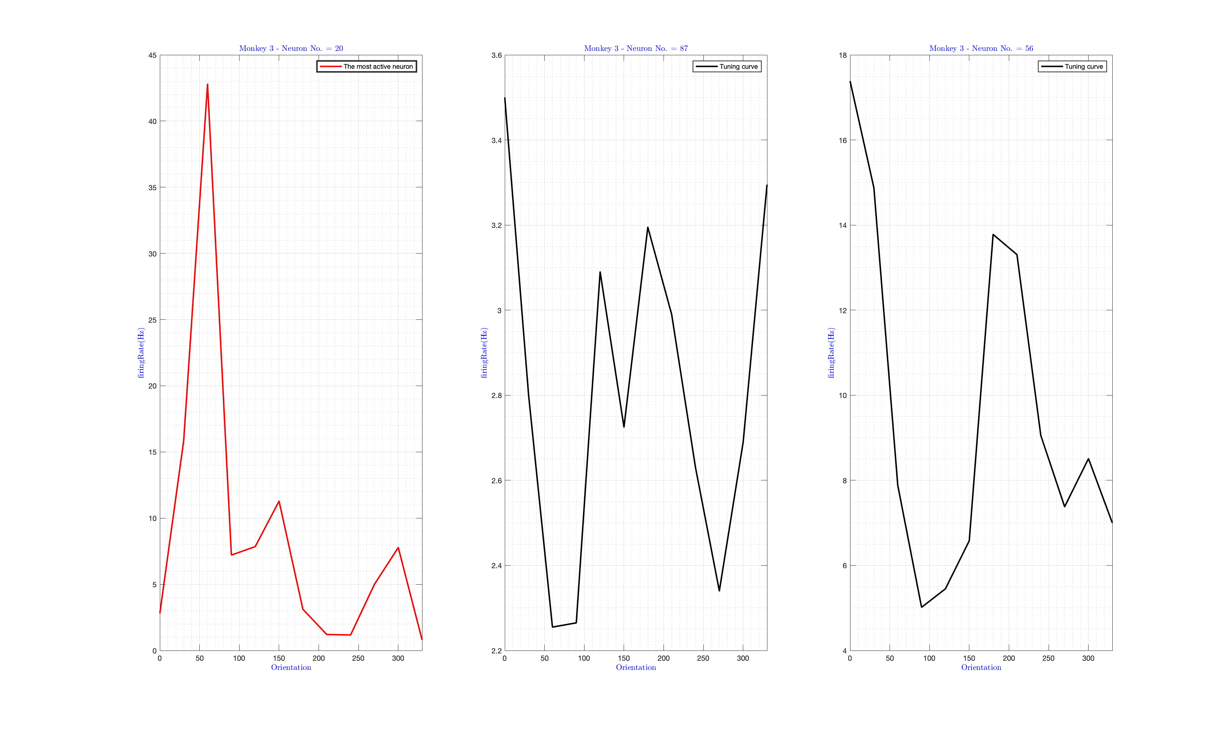

So the most active neuron in Monkey1, two and are 25, 45, and 20, respectively

Note: As the Figure indicates, the tuning curves have two peaks with 180-degree differences. The reason is that the stimulus movies for supplementary angles are the same.

This explains that most of the neurons have two preferred orientations that are 180 degrees apart, meaning if they respond to a certain angle, they also respond to the opposite angle. However, some neurons only have one preferred orientation.

Also, I plotted the average tuning curve for all the neurons for each monkey, and this is the result: 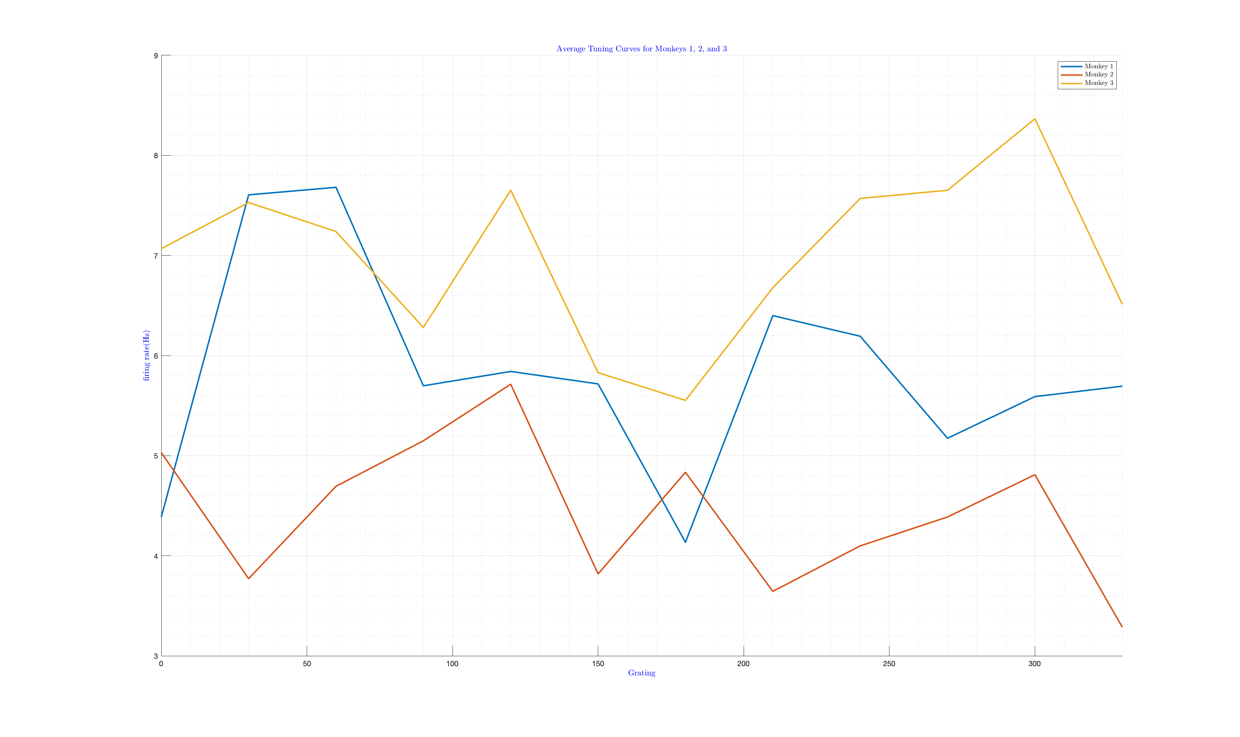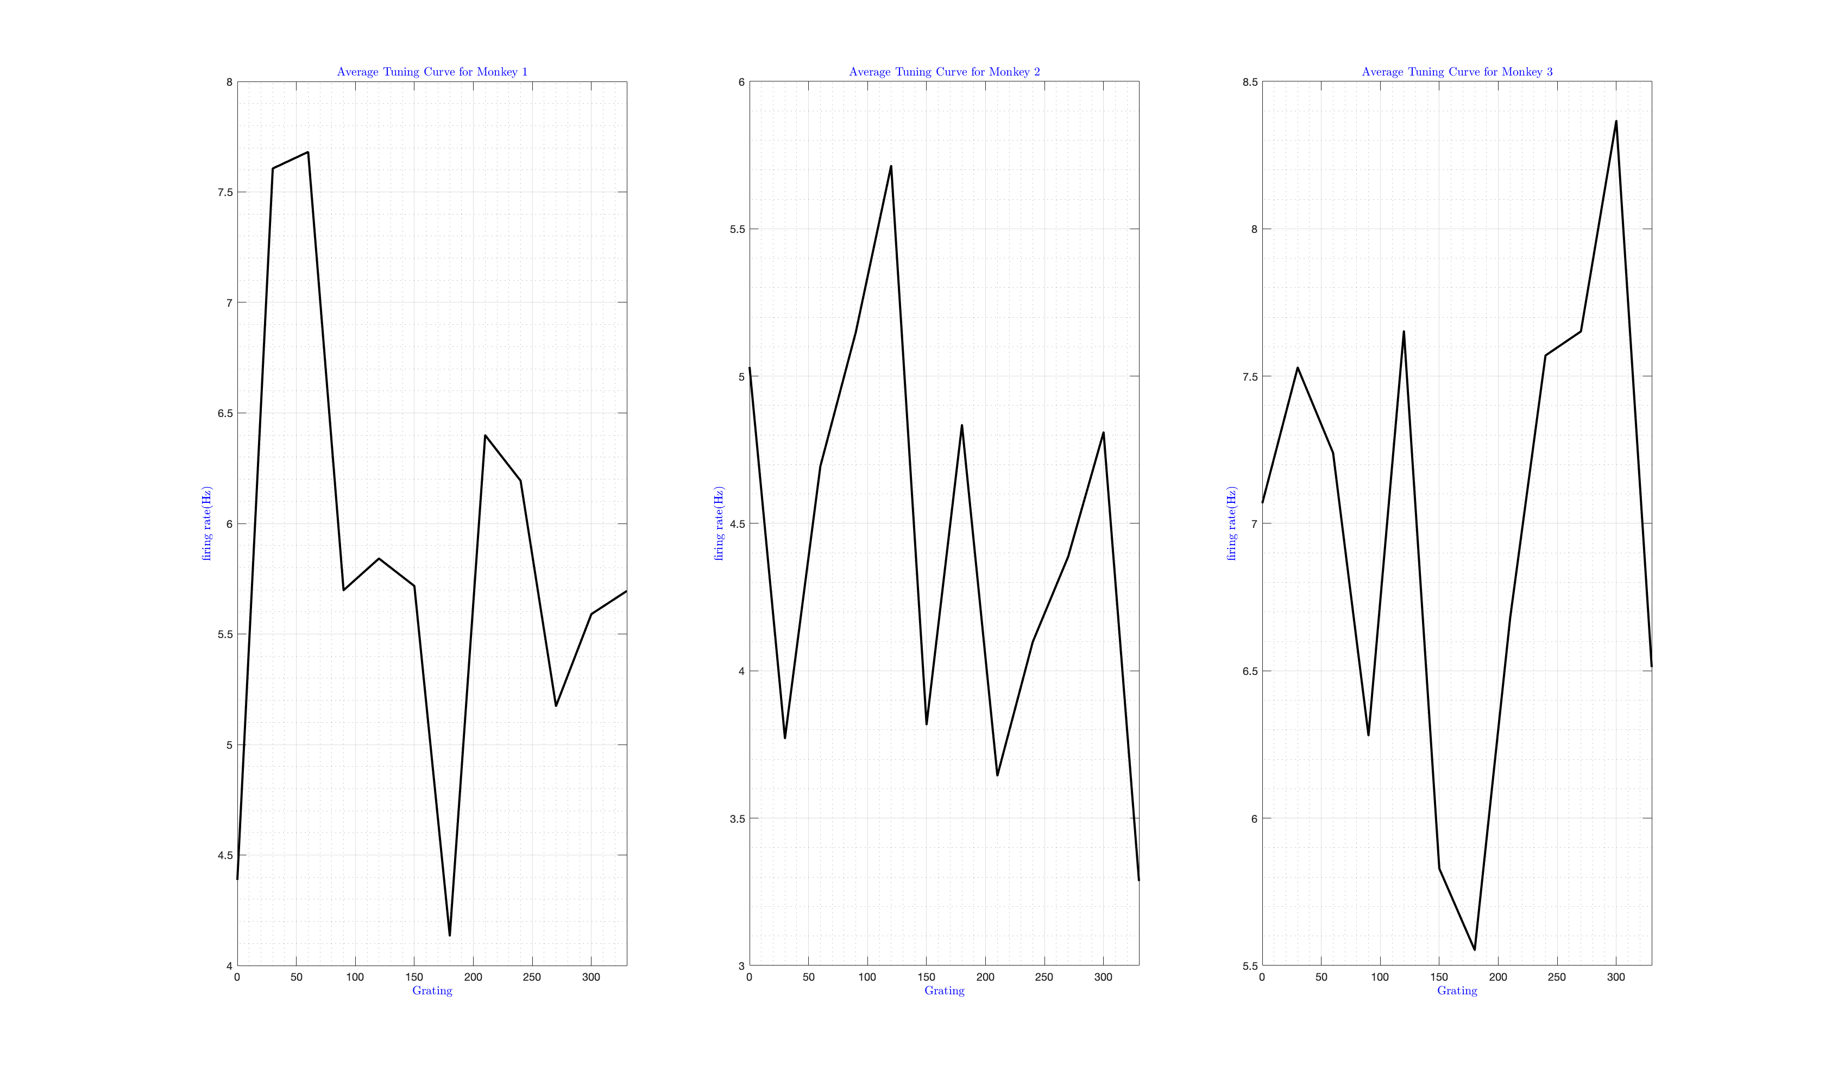

1. **Part 2**

The preferred orientation of each neuron is the one with the most remarkable mean firing rate.

The data is collected using a 10x10 array, which allows us to create a plot that displays the preferred orientation of neurons at the positions of the electrodes. To do this, I identified the neurons associated with each unit and used their preferred orientation to represent the neurons at the electrode's location.

Ideally, we would have a complete 10x10 plot; however, due to the exclusion of data from some neurons with an inadequate signal-to-noise ratio (SNR) and firing rate(the neurons deleted in pre-process section), there are many locations where we need more data to determine the preferred orientation. As a result, these locations have "NaN" (Not a Number) values. This relates to the periodic nature of angles and their representation in the plot. So I plot in two different styles. First, I plotted with the NaN area to show how much data we need, and second I plotted without Nan. And this is the result:

**Monkey-1:**

* **With NaN area:** 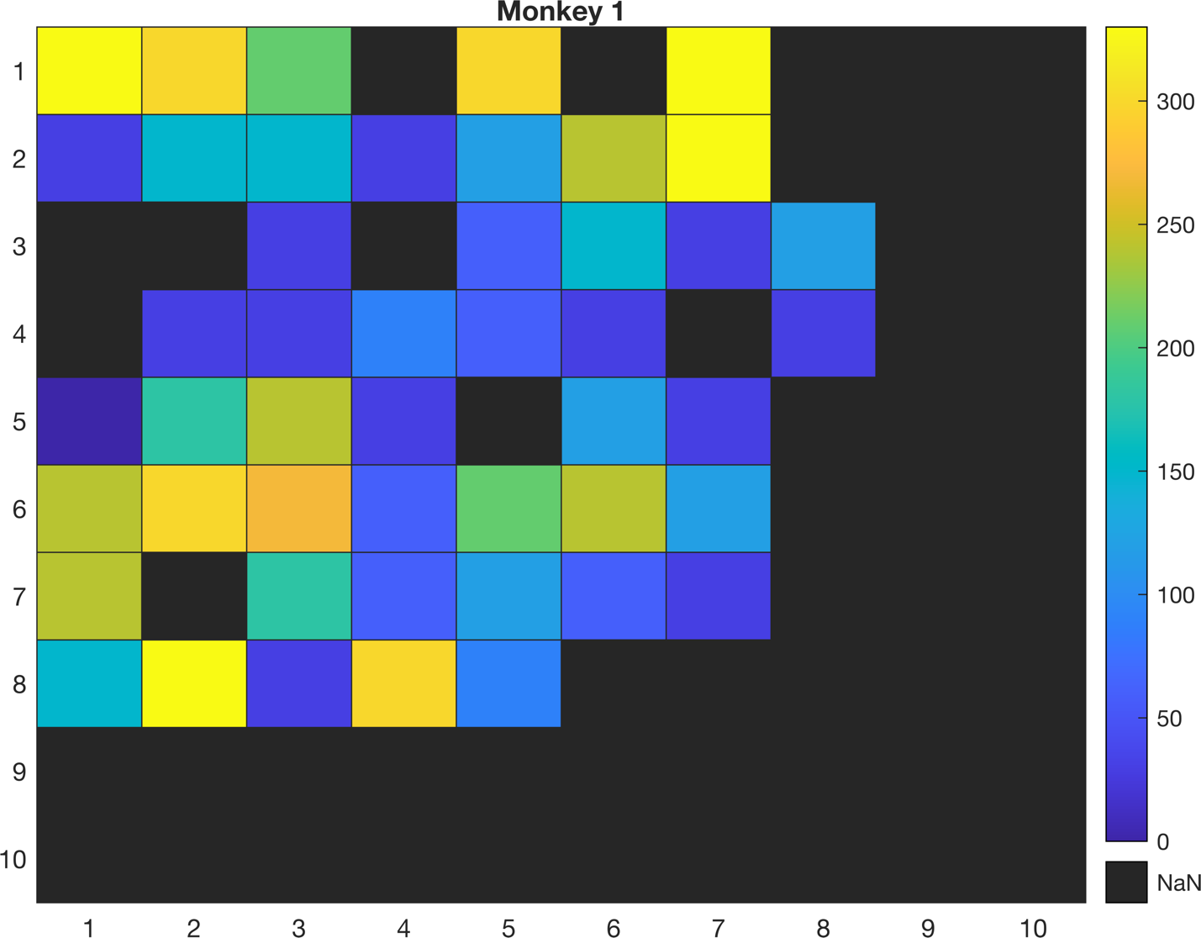
* **Without NaN area:** 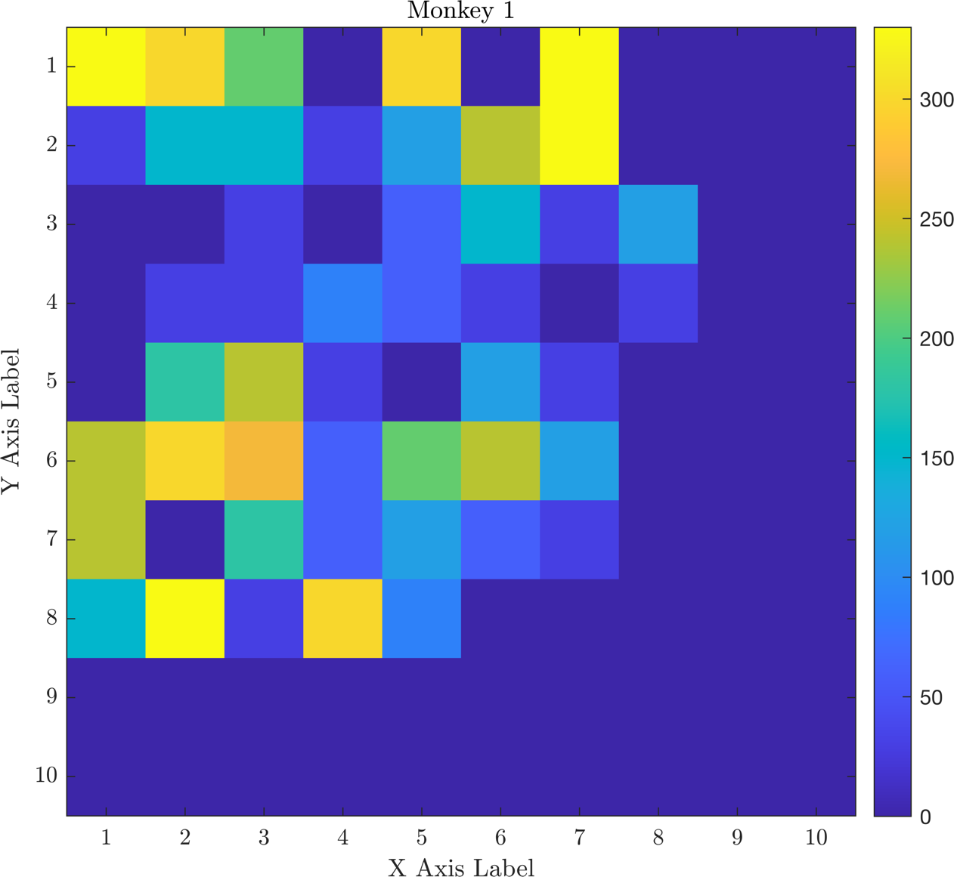

**Monkey-2:**

* **With NaN area:** 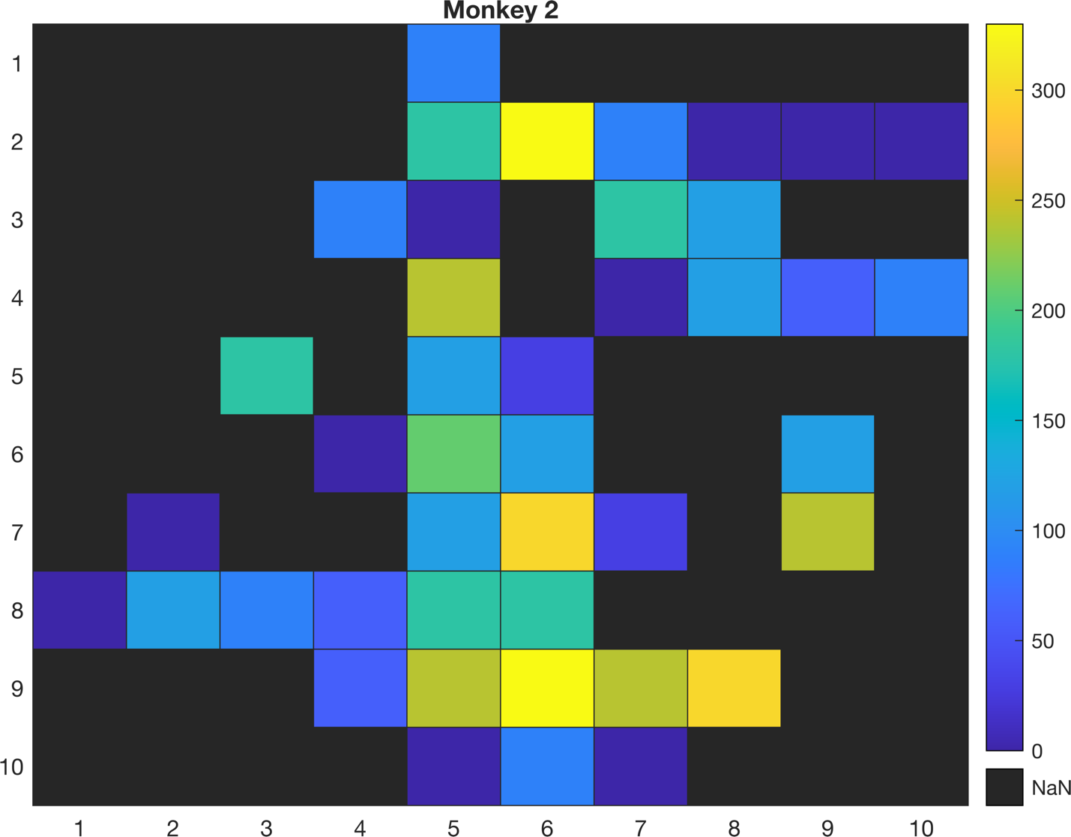
* **Without NaN area:** 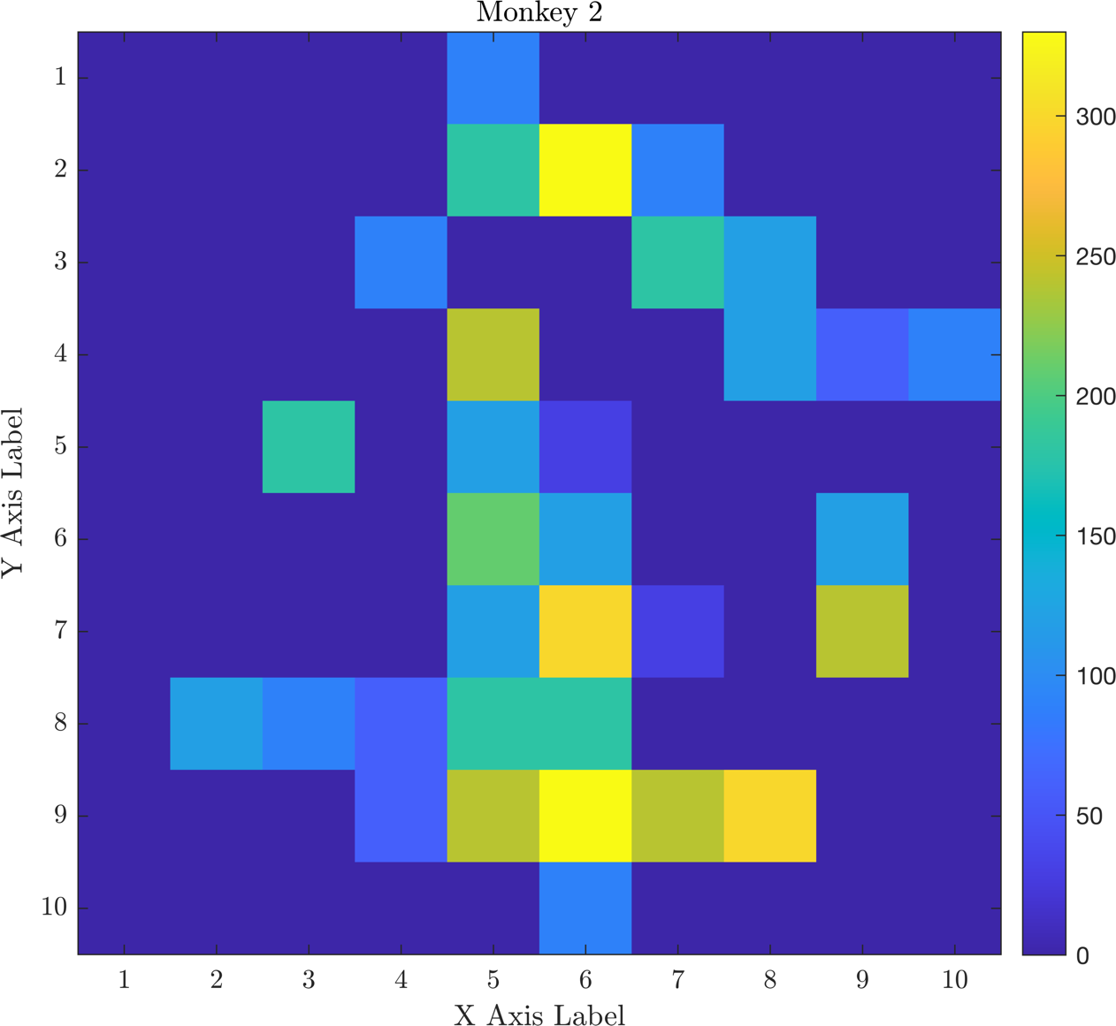

**Monkey-3:**

* **With NaN area:** 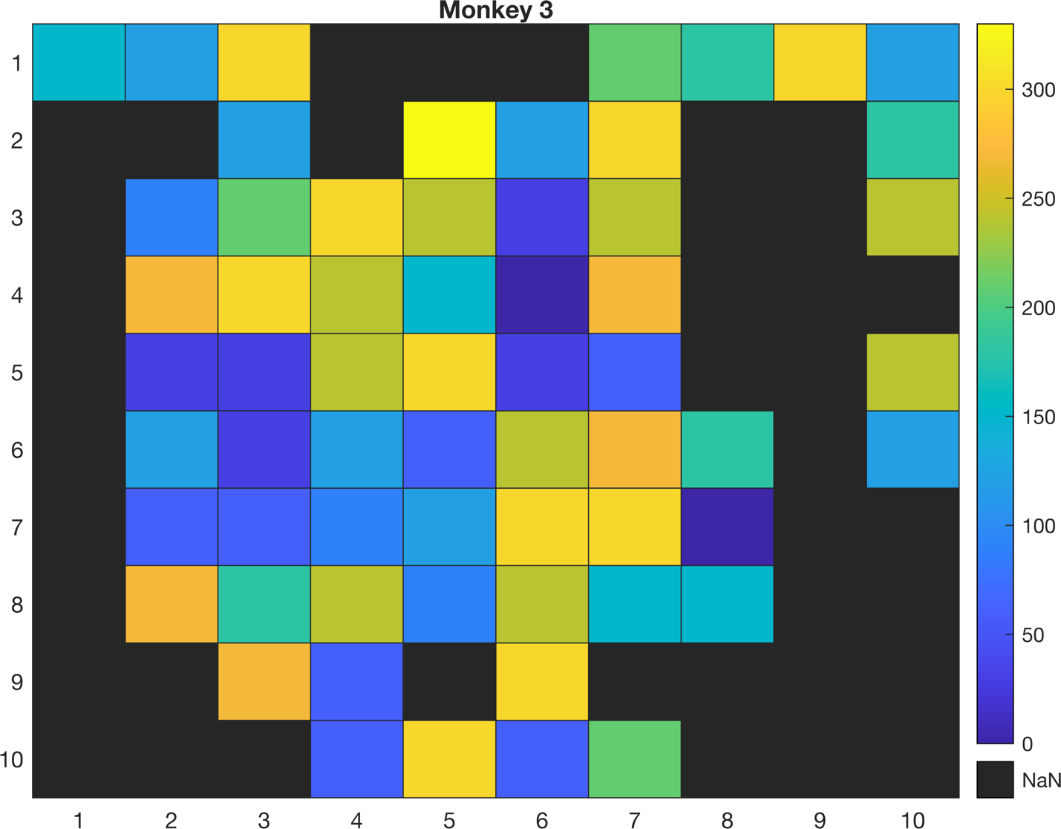
* **Without NaN area:** 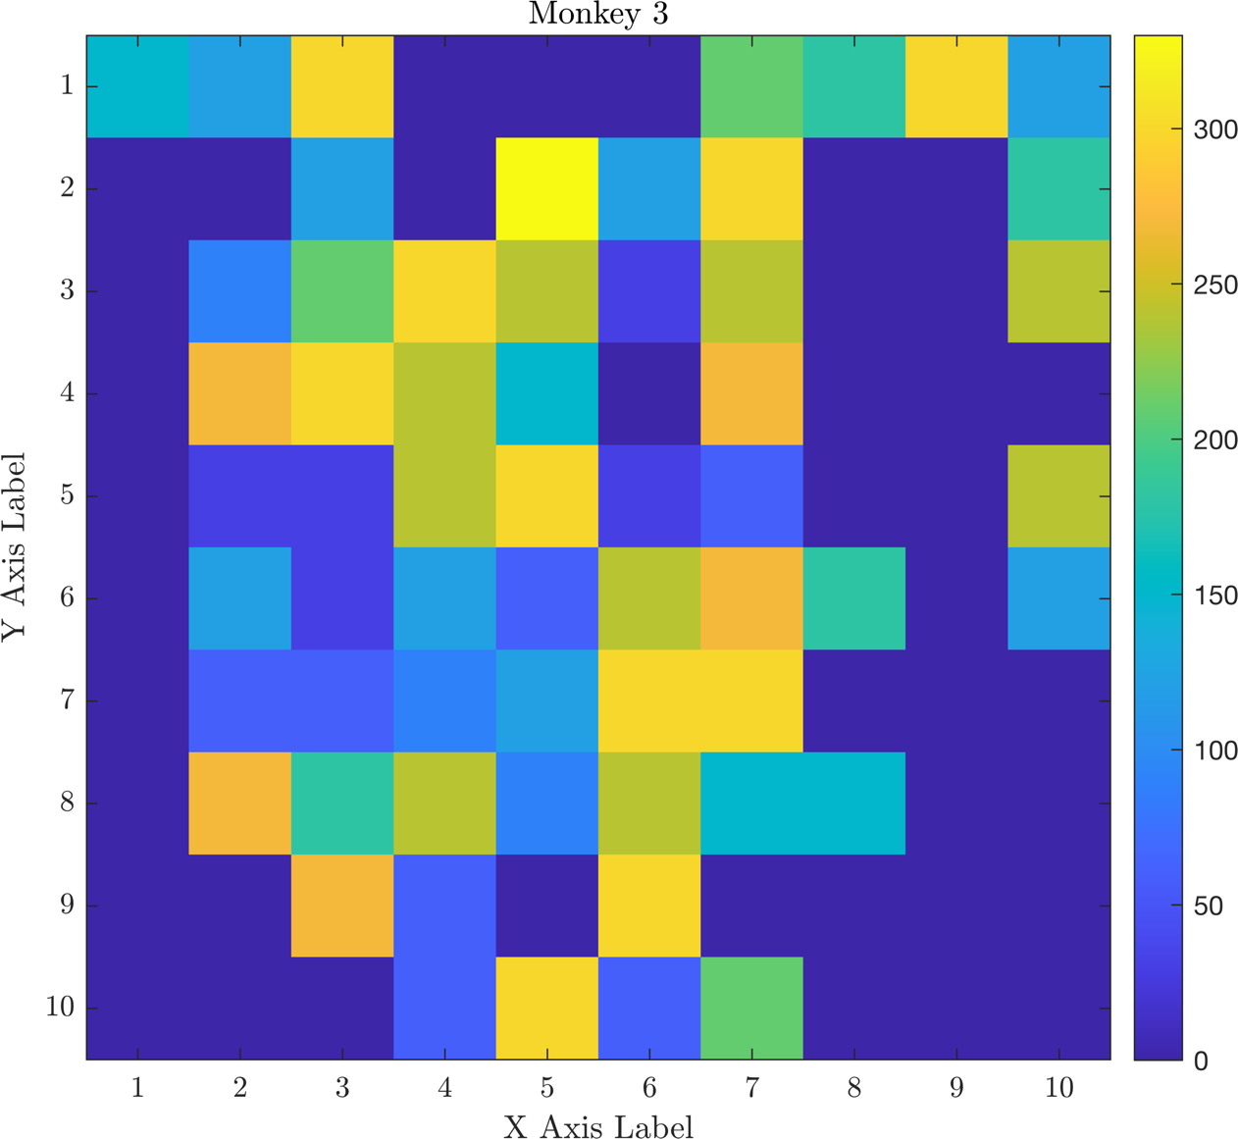

** I replaced the zero with NaN value

**Question**: Are your results similar to the pinwheel organization of orientation in the cortex? Why or why not?

**Answer:** We observe that the majority of neighboring cells tend to share similar orientations. However, the plot's accuracy could be improved. Increasing spatial precision and utilizing more neurons for detecting orientation may be necessary. Also, It‘s probably because of the low spatial resolution in our data.

1. **Part 3**

I attempted to study the relationship between signal correlation and noise correlation using the method outlined in the paper by Smith and Kohn (2008), which focuses on the spatial and temporal scales of neuronal correlation in the primary visual cortex.

I determined the signal correlation for each neuron pair by assessing the correlation between the neuron's tuning curves. I also calculated the noise correlation. As mentioned in the paper, I used Z-score normalization for each orientation to obtain a mean of zero and unit variance. Then I calculated the signal correlation after combining responses to all stimuli.

To recreate Figure 3 from the paper, I first divided the data into four groups based on the distance between recorded neurons and examined their relationships. Next, I separated the data into four groups based on signal correlation.

**Monkey-1:**

**Noise Correlation vs. Electrode distances in 4 different groups:** 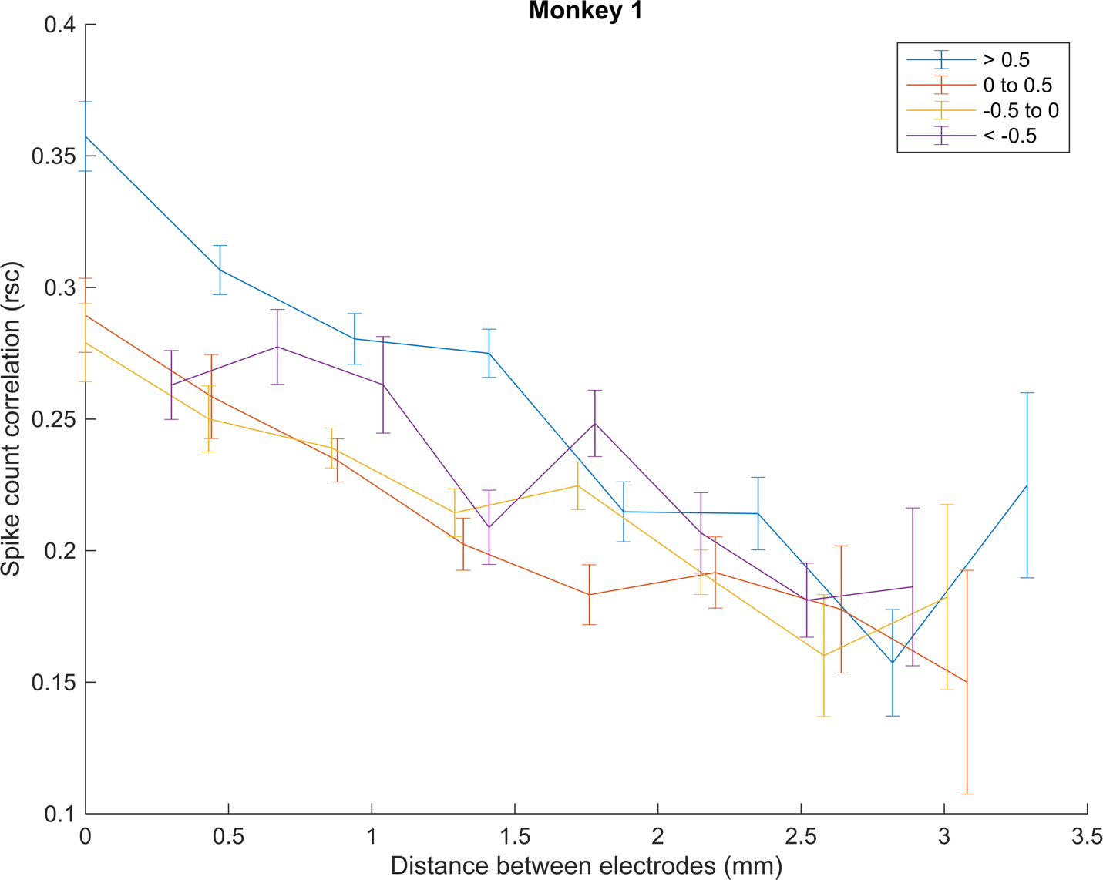

**Noise Correlation vs. Signal Correlation in 4 different groups**: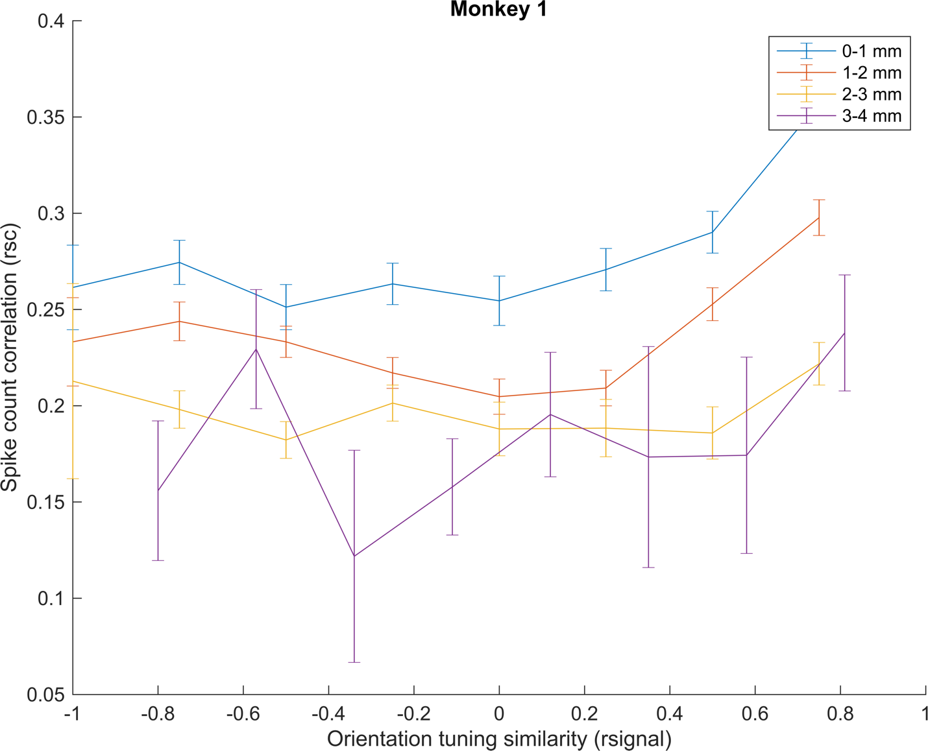

**Noise Correlation vs. Electrode distances & Signal Correlation**: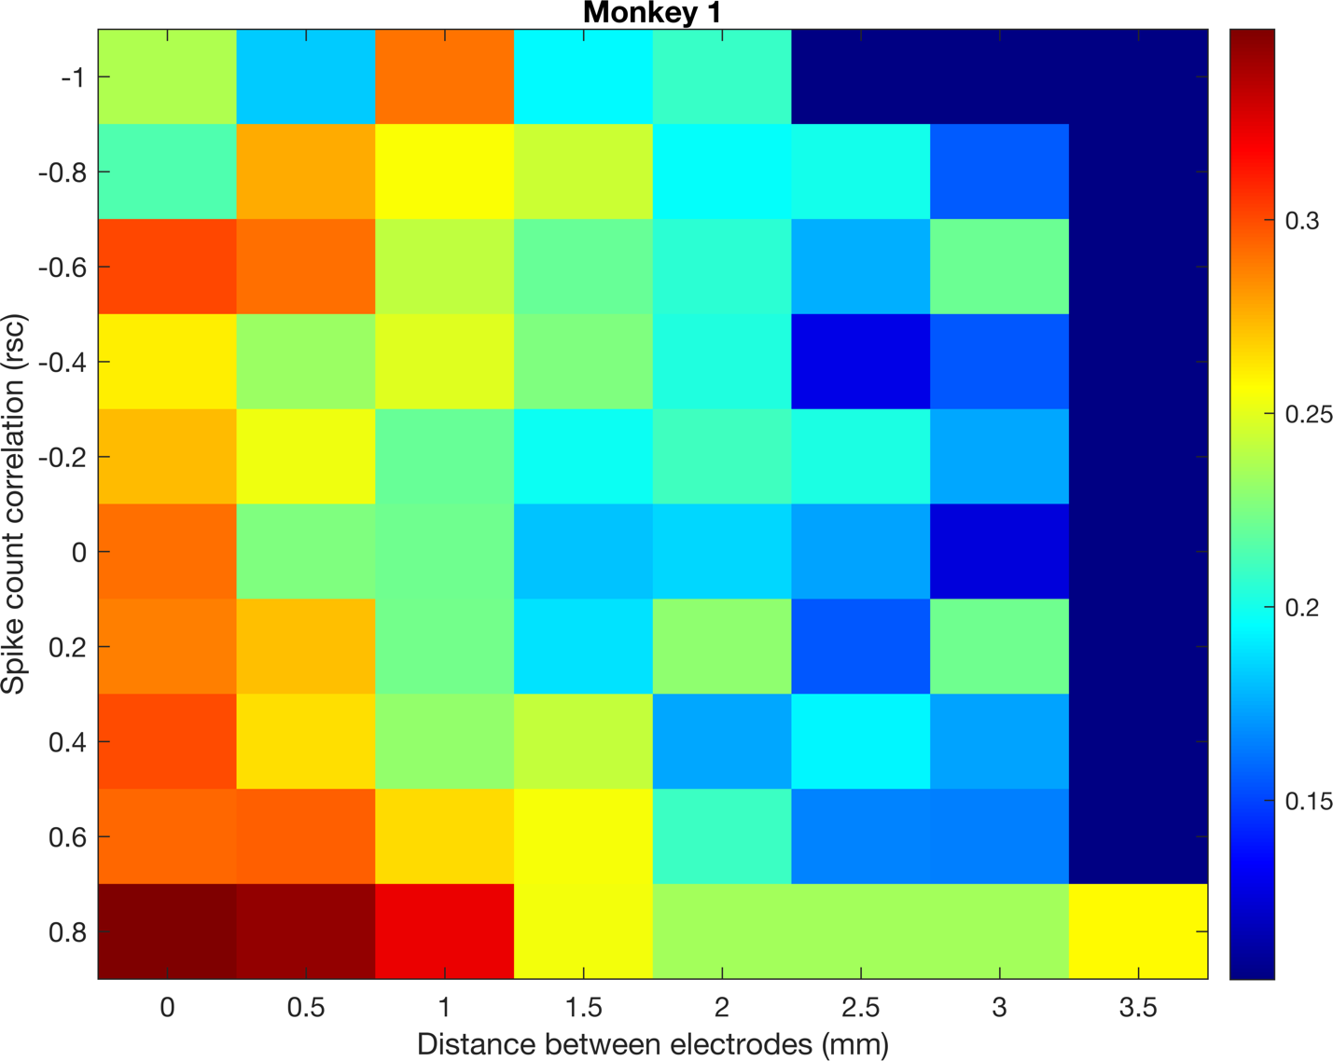

**Monkey-2:**

**Noise Correlation vs. Electrode distances in 4 different groups**: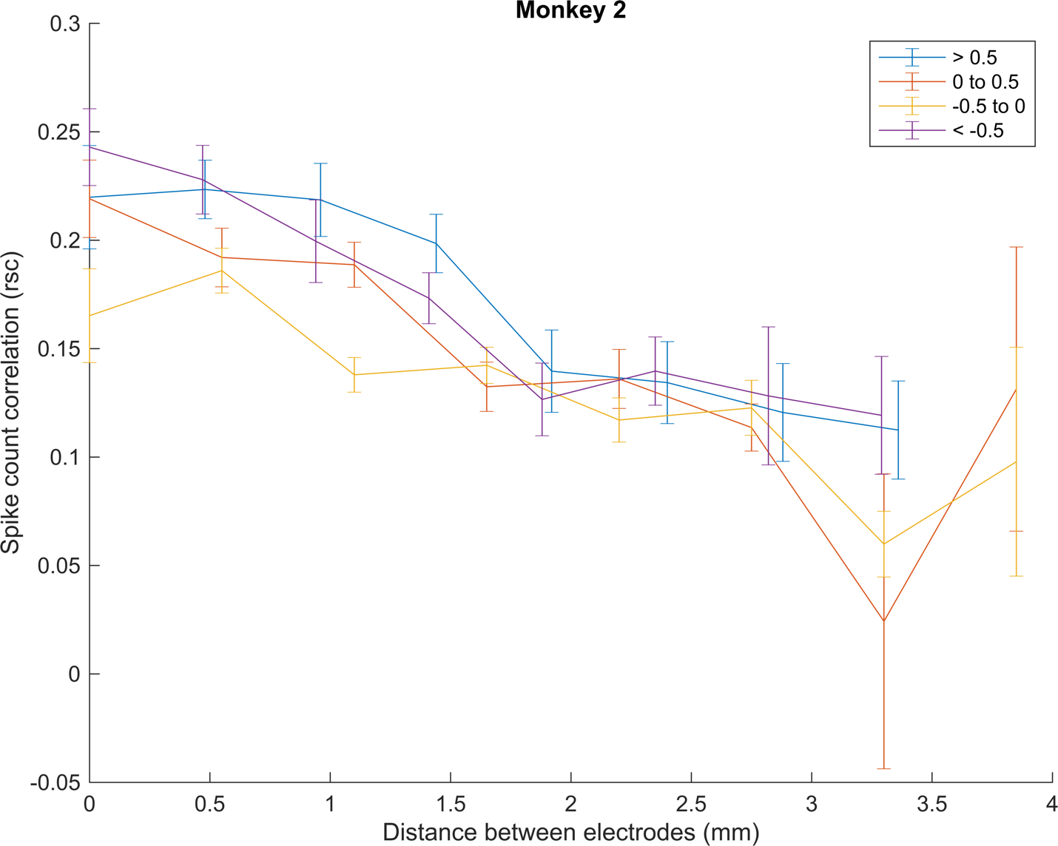

**Noise Correlation vs. Electrode distances & Signal Correlation**: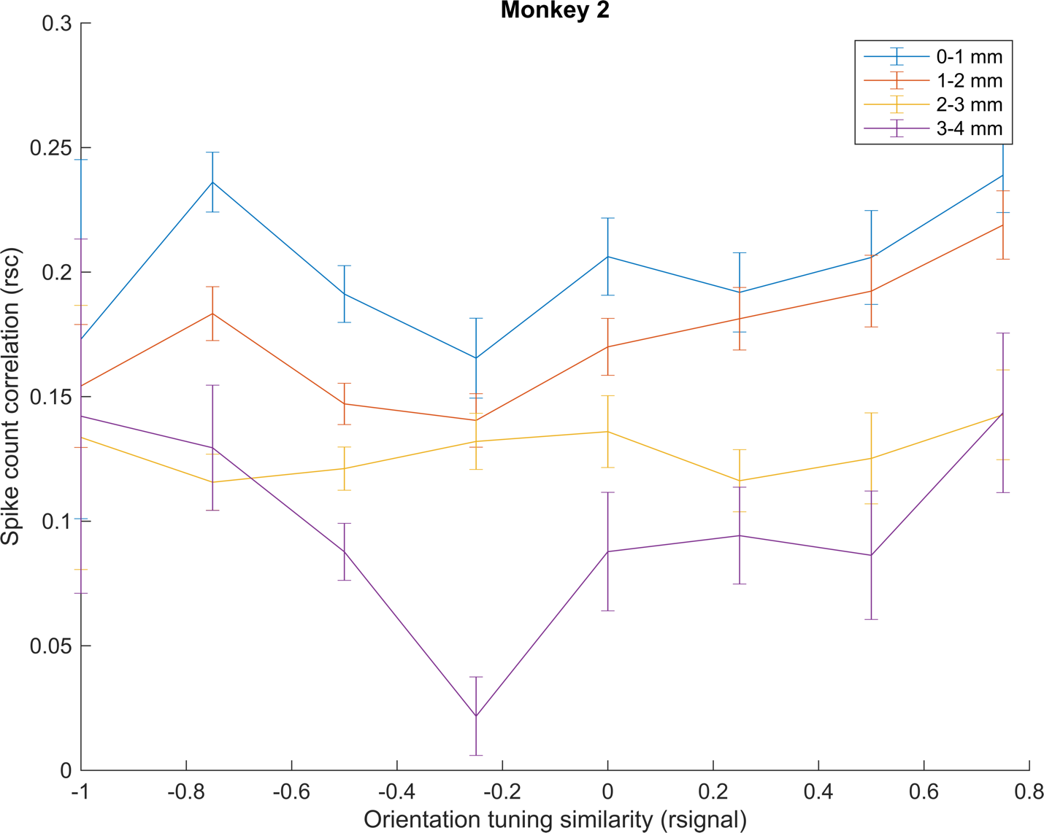

**Noise Correlation vs. Signal Correlation in 4 different groups**: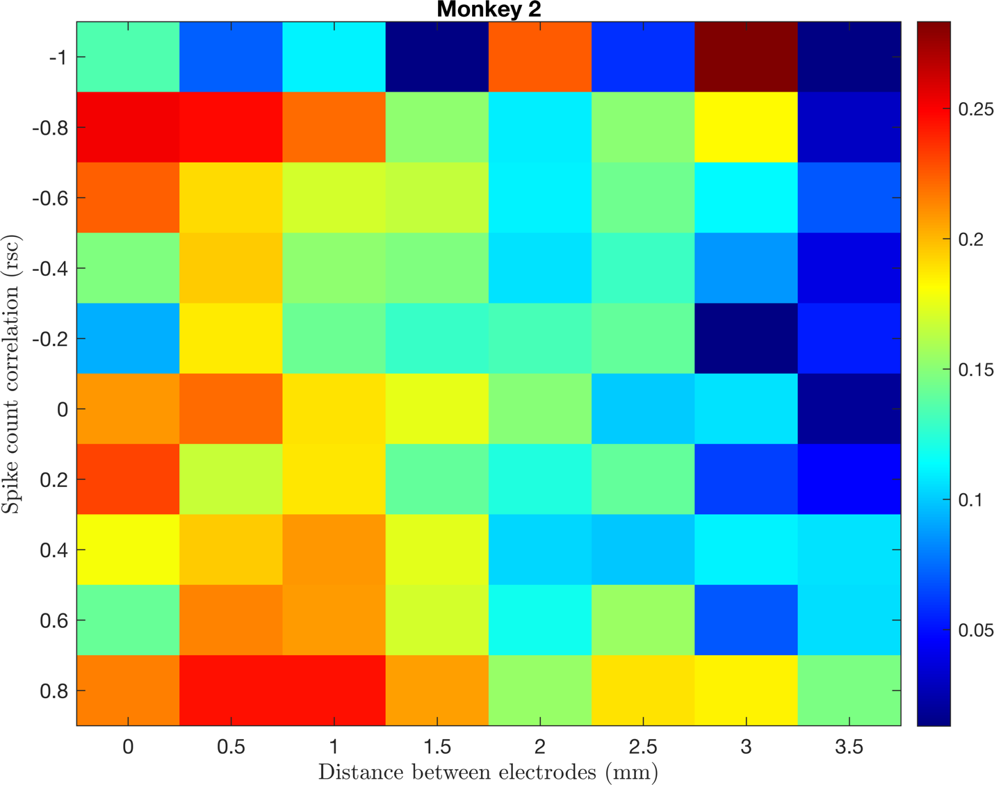

**Monkey-3:**

**Noise Correlation vs. Electrode distances in 4 different groups**: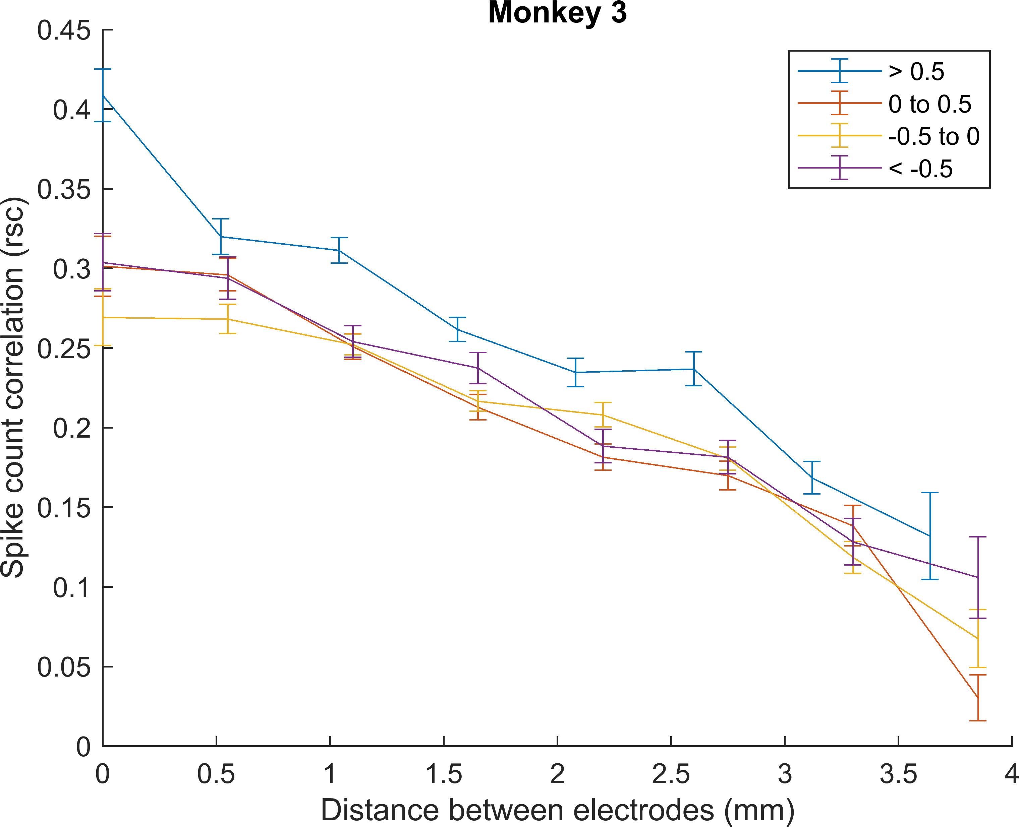

**Noise Correlation vs. Electrode distances & Signal Correlation**: 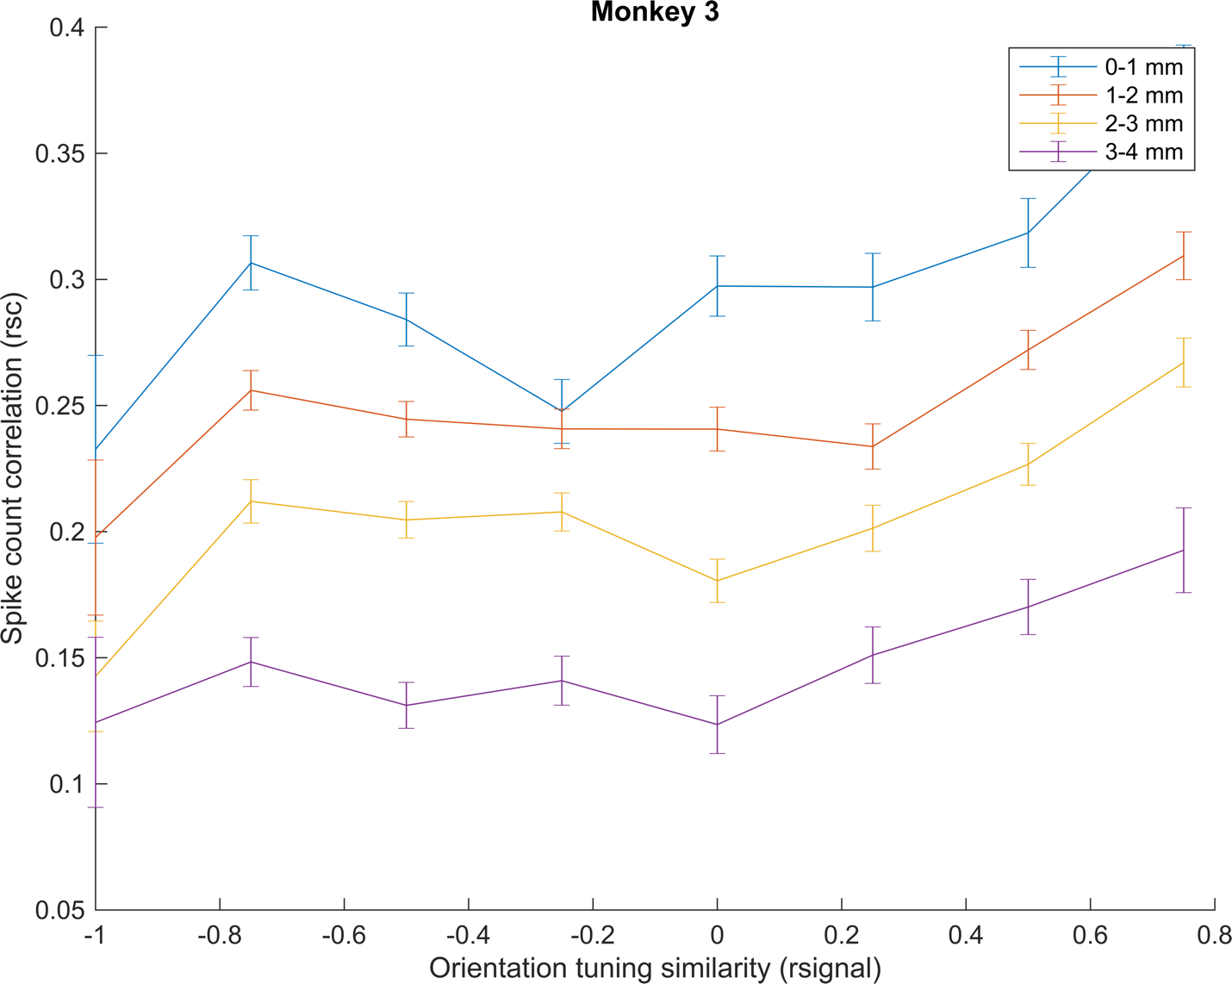

**Noise Correlation vs. Signal Correlation in 4 different groups**: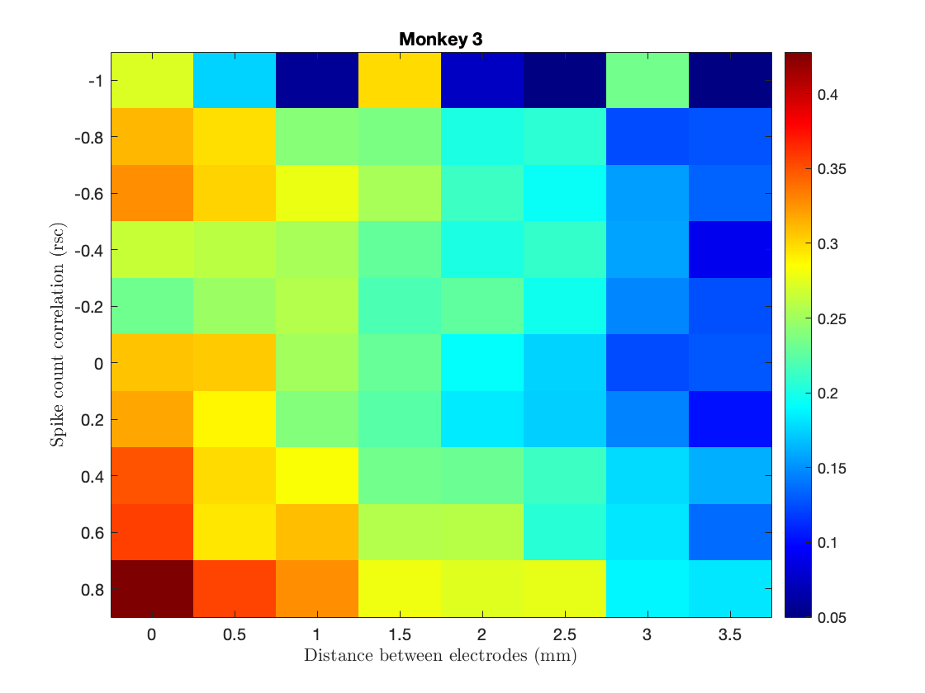

**Question:** Is your answer similar with the paper's conclusion?

**Answer:** The observed results are consistent with those reported in the paper, demonstrating a relationship between neuronal activity and the signal/noise correlation concerning distance. Higher correlations are associated with shorter distances, while lower correlations are observed at greater distances.

1. **Part 4**

**Question:** the average rsc value for spontaneous activity was 0.299, nearly twofold higher than the average correlation of evoked activity (0.176) in the dataset. How can you explain the difference in correlation between evoked and spontaneous periods?

**Answer:** Brain activity happens naturally when no stimulus (external input), and neurons work more in sync. This is called spontaneous activity. When a specific stimulus is introduced, neurons react to it, which is called evoked activity. In this case, the neurons responding to the stimulus work more independently, causing less synchronization. As a result, the noise in the system is generally reduced during evoked activity compared to spontaneous activity.

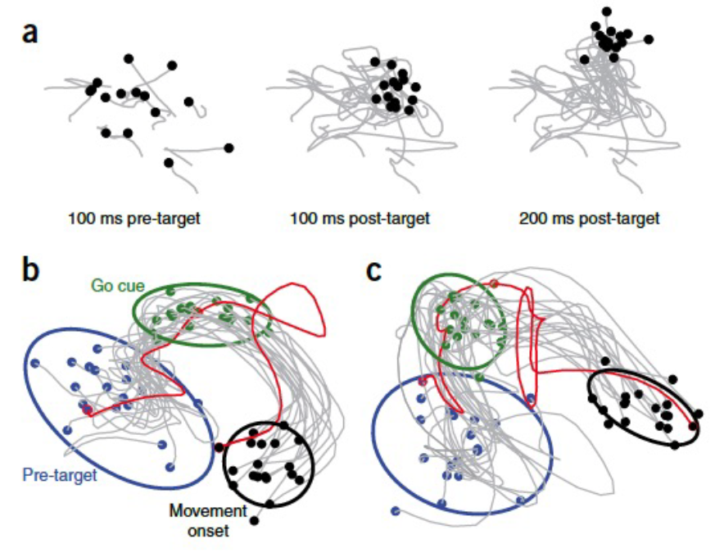

1. **Part 5**

**Question:** So we know that the neurons with similar orientation preferences are highly correlated with each other. Can we use this fact and compute color mesh (in question2) from spontaneous activity of neurons? Explain your approach

**Answer:** While it is true that neurons with similar orientation preferences exhibit a high correlation, deriving a color mesh from the spontaneous activity of neurons is not a straightforward task. Spontaneous activity refers to the neural activity that occurs in the absence of external stimuli, which means the neurons' specific orientation preferences are not directly engaged during this period. Also, we cannot compute the color mesh for spontaneous activity because there is just one condition.